** D. Y. PATIL COLLEGE OF ENGINEERING, AKURDI, PUNE**

**Department of Artificial Intelligence and Data Science**

**2023-24**

**LAB MANUAL**

**Computer Laboratory-IV**

**(BE)**

**Semester II**

**D Y Patil College of Engineering, Akurdi, Pune**

**Department of Artificial Intelligence & Data Science**

Vision of Institute

“Empowerment through knowledge”

**Mission of Institute**

1. To educate the students to transform them as professionally competent and quality conscious engineers.
2. To Provide Conducive Environment for Teaching Learning and overall personality development.
3. To culminate the Institute into an International seat of excellence

**VISION of Department**

Developing highly skilled and competent IT professional for sustainable growth in the field of Artificial Intelligence and Data science.

**MISSION of Department**

1. To empower students for developing intelligent systems and innovative products for societal problems.
2. To build strong foundation in Data computation, Intelligent Systems that enables self-development entrepreneurship and Intellectual property.
3. To develop competent and skilled IT professional by imparting global skills and technologies for serving society.

**D Y Patil College of Engineering, Akurdi, Pune**

**Department of Artificial Intelligence & Data Science**

**Program Outcomes (PO’s)**

|  |  |  |
| --- | --- | --- |
| PO1 | Engineering knowledge | Apply the knowledge of mathematics, science, Engineering fundamentals, and an Engineering specialization to the solution of complex Engineering problems. |
| PO2 | Problem analysis | Identify, formulate, review research literature and analyze complex Engineering problems reaching substantiated conclusions using first principles of mathematics, natural sciences and Engineering sciences. |
| PO3 | Design / Development of Solutions | Design solutions for complex Engineering problems and design system components or processes that meet the specified needs with appropriate consideration for the public health and safety, and the cultural, societal, and Environmental considerations. |
| PO4 | Conduct Investigations of Complex Problems | Use research-based knowledge and research methods including design of experiments, analysis and interpretation of data, and synthesis of the information to provide valid conclusions. |
| PO5 | Modern Tool Usage | Create, select, and apply appropriate techniques, resources, and modern Engineering and IT tools including prediction and modeling to complex Engineering activities with an understanding of the limitations. |
| PO6 | The Engineer and Society | Apply reasoning informed by the contextual knowledge to assess societal, health, safety, legal and cultural issues and the consequent responsibilities relevant to the professional engineering practices. |
| PO7 | Environment and Sustainability | Understand the impact of the professional Engineering solutions in societal and Environmental contexts, and demonstrate the knowledge of, and need for sustainable development. |
| PO8 | Ethics | Apply ethical principles and commit to professional ethics and responsibilities and norms of Engineering practice. |
| PO9 | Individual and Team Work | Function effectively as an individual, and as a member or leader in diverse teams, and in multidisciplinary settings. |
| PO10 | Communication  Skills | Communicate effectively on complex Engineering activities with the Engineering community and with society at large, such as, being able to comprehend and write effective reports and design documentation, make effective presentations, and give and receive clear instructions. |
| PO11 | Project Management and Finance | Demonstrate knowledge and understanding of Engineering and management principles and apply these to one’s own work, as a member and leader in a team, to manage projects and in multidisciplinary Environments. |
| PO12 | Life-long Learning | Recognize the need for, and have the preparation and ability to engage in independent and life-long learning in the broadest context of technological change. |



**D Y Patil College of Engineering, Akurdi, Pune**

**Department of Artificial Intelligence & Data Science**

**Program Specific Outcomes (PSO’s)**

|  |  |  |
| --- | --- | --- |
| PSO1 | Professional Skills | The ability to understand, analyze and develop computer programs in the areas related to algorithms, system software, multimedia, web design, networking, artificial intelligence and data science for efficient design of computer-based systems of varying complexities. |
| PSO2 | Problem-Solving Skills | The ability to apply standard practices and strategies in software project development using open-ended programming environments to deliver a quality product for business success. |
| PSO3 | Successful Career and Entrepreneurship | The ability to employ modern computer languages, environments and platforms in creating innovative career paths to be an entrepreneur and to have a zest for higher studies. |

**Program Educational Objective (PEO’s)**

|  |  |
| --- | --- |
| PEO1 | To prepare globally competent graduates having strong fundamentals and domain knowledge to provide effective solutions for engineering problems. |
| PEO2 | To prepare the graduates to work as a committed professional with strong professional ethics and values, sense of responsibilities, understanding of legal, safety, health, societal, cultural and environmental issues. |
| PEO3 | To prepare committed and motivated graduates with research attitude, lifelong learning, investigative approach, and multidisciplinary thinking. |
| PEO4 | To prepare the graduates with strong managerial and communication skills to work effectively as individual as well as in teams. |

**Computer Laboratory -IV**

|  |  |  |  |
| --- | --- | --- | --- |
| **Course Code** | **Course Name** | **Teaching Scheme (Hrs./ Week)** | **Credits** |
| 417532D | Computer Laboratory-IV: Deep Learning | 2 | 2 |
| 417533B | Computer Laboratory-IV:  Business Intelligence | 2 | 2 |
| 417532B | Computer Laboratory-IV:  Big Data Analysis | 2 | 2 |
| 417533D | Computer Laboratory-IV:  Reinforcement Learning | 2 | 2 |

## Course Objectives:

## To understand the fundamental concepts and techniques of Virtual reality

## • To understand Big Data Analytics Concepts

## • To learn the fundamentals of software development for portable devices

## • To understand fundamental concepts of Deep Learning

## • To be familiar with the various application areas of augmented realities

## • To introduce the concepts and components of Business Intelligence (BI)

## • To understand the concepts of Information Systems

## Course Outcomes:

On completion of the course, learner will be able to–

CO1: Apply basic principles of elective subjects to problem solving and modeling

CO2: Use tools and techniques in area of software development to build mini projects

CO3: Design and develop applications on subjects of their choice

CO4: Implement and manage deployment, administration & security

**Operating System recommended:** Practical can be performed on suitable development platform

**Table of Contents**

|  |  |  |  |
| --- | --- | --- | --- |
| **Sr. No** | **Title of Experiment** | **CO**  **Mappi ng** | **Page No** |
| **Deep Learning** | | | |
| 1 | Build a Multiclass classifier using the CNN model. Use MNIST or any other suitable dataset. a. Perform Data Pre-processing   1. Define Model and perform training 2. Evaluate Results using confusion matrix. | CO1, CO2 | 13 |
| 2 | Design RNN or its variant including LSTM or GRU  a) Select a suitable time series dataset. E.g - Predict sentiments based on product reviews. b) Apply for prediction | CO1, CO2 | 18 |
| 3 | Design and implement a CNN for Image Classification a) Select a suitable image classification dataset (medical imaging, agricultural, etc.). b) Optimized with different hyper-parameters including learning rate, filter size, no. of layers, optimizers, dropouts, etc | CO1,CO2 | 24 |
| 4 | Design and implement Deep Convolutional GAN to generate images of faces/digits from a set of given images. | CO2 | 30 |
| 5 | Problem Statement – Real estate agents want help to predict the house price for regions in the USA. He gave you the dataset to work on and you decided to use the Linear Regression Model. Create a model that will help him to estimate what the house would sell for. URL for a dataset:  https://github.com/huzaifsayed/Linear-Regression-Model-for-House-PricePrediction/blob/master/USA_Housing.csv | CO1 | 05 |
|  |  |  |  |
| **Business Intelligence** | | | |
| 6 | Import Data from different Sources such as (Excel, Sql Server, Oracle etc.) and load in targeted system. | CO1 | 38 |
| 7 | Data Visualization from Extraction Transformation and Loading (ETL) Process. | CO2 | 44 |
| 8 | Perform the Extraction Transformation and Loading (ETL) process to construct the database in the Sql server / Power BI. | CO3 | 49 |
| 9 | Data Analysis and Visualization using Advanced Excel | CO 4 | 55 |
| 10 | Perform the data classification algorithm using any Classification algorithm | CO 5 |  |
|  | **Big Data Analytics** |  |  |
| 11 | Develop a MapReduce program to calculate the frequency of a given word in a given file. |  |  |
| 12 | Develop a MapReduce program to find the grades of student’s**.** |  |  |
| 13 | Implement Matrix Multiplication using Map Reduce |  |  |
| 14 | Develop a MapReduce program to analyze Titanic ship data and to find the average age of the people (both male and female) who died in the tragedy. How many persons are survived in each class. |  |  |
| 15 | Hive: Introduction Creation of Database and Table, Hive Partition, Hive Built in Function and Operators, Hive View and Index. |  |  |
|  | **Reinforcement Learning** |  |  |
| 16 |  |  |  |
| 17 | Implement a Deep Q-Network (DQN) using a deep neural network library (e.g., TensorFlow or PyTorch) and train it on a simple environment like CartPole or Mountain Car. |  |  |
| 18 |  |  |  |
| 19 |  |  |  |
| 20 |  |  |  |

|  |  |
| --- | --- |
| **Lab Assignment**  **No.** | 1 |
| **Title** | Problem Statement – Real estate agents want help to predict the house price for regions in the USA. He gave you the dataset to work on and you decided to use the Linear Regression Model. Create a model that will help him to estimate what the house would sell for. URL for a dataset:  https://github.com/huzaifsayed/Linear-Regression-Model-for-House-PricePrediction/blob/master/USA_Housing.csv |
| **Roll No.** |  |
| **Class** | BE |
| **Date of Completion** |  |
| **Subject** | Computer Laboratory-III-Computational Intelligence |
| **Assessment Marks** |  |
| **Assessor's Sign** |  |

# ASSIGNMENT No: 01

**Title:-** Problem Statement – Real estate agents want help to predict the house price for regions in the USA. He gave you the dataset to work on and you decided to use the Linear Regression Model. Create a model that will help him to estimate what the house would sell for. URL for a dataset:

[https://github.com/huzaifsayed/Linear-Regression-Model-for-House-Price Prediction/blob/master/USA_Housing.csv](https://github.com/huzaifsayed/Linear-Regression-Model-for-House-Price%20Prediction/blob/master/USA_Housing.csv)

**Objective:**

Develop a model to estimate house prices based on relevant features using Linear Regression.

## Outcome-

* Apply Linear Regression in a real-world scenario.
* Understand the implementation of a regression model for house price prediction.



* Python (3.x recommended)
* Jupyter Notebook or any Python IDE

**Hardware Requirement**

A machine with sufficient RAM and processing power for model training (8GB RAM recommended)



* Basic understanding of Python programming
* Familiarity with the concepts of supervised learning

## What is Linear Regressoin?

## When we see a relationship in a scatterplot, we can use a line to summarize the relationship in the data. We can also use that line to make predictions in the data. This process is called .Linear Regression is a supervised learning algorithm used for predicting a continuous outcome, typically represented by the target variable. In the context of this assignment, we aim to predict house prices based on various features such as area income, house age, number of rooms, and others.



## Linear regression is used to study the linear relationship between a dependent variable Y (blood pressure) and one or more independent variables X (age, weight, sex).

## The dependent variable Y must be continuous, while the independent variables may be either continuous (age), binary (sex), or categorical (social status). The initial judgment of a possible relationship between two continuous variables should always be made on the basis of a scatter

## plot (scatter graph). This type of plot will show whether the relationship is linear (figure 1) or nonlinear (figure 2).

## 

|  |
| --- |
| Figure 1 A scatter plot showing a linear relationship |

## 

|  |
| --- |
| Figure 2 A scatter plot showing an exponential relationship. In this case, it would not be appropriate to compute a coefficient of |



The formula for a simple linear regression is:



•  is the predicted value of the dependent variable ( ) for any given value of the

independent variable ( ).

* is the  , the predicted value of  when the  is 0.
* is the regression coefficient – how much we expect  to change as  increases.
* is the independent variable ( the variable we expect is influencing ).
* is the  of the estimate, or how much variation there is in our estimate of the regression coefficient.

Linear regression finds the line of best fit line through your data by searching for the regression coefficient (B1) that minimizes the total error (e) of the model.

While you can perform a linear regression by hand, this is a tedious process, so most people use statistical programs to help them quickly analyze the data.



Training a regression model involves teaching the model to predict continuous values based on input features. Here's a brief explanation of the process, along with some images to illustrate key concepts.

Regression Model Training:

1. Data Collection: Gather a dataset with input features (independent variables) and corresponding target values (dependent variable).
2. Data Splitting: Split the dataset into training and testing sets. The training set is used to train the model, and the testing set is used to evaluate its performance.
3. Model Selection: Choose a regression model architecture. Common choices include linear regression, decision trees, or more complex models like neural networks.
4. Feature Scaling: Normalize or standardize the input features to ensure that they are on a similar scale. This helps the model converge faster during training.
5. Model Training: Feed the training data into the chosen model and adjust the model's parameters to minimize the difference between predicted and actual target values.
6. Loss Function: Use a loss function to measure the difference between predicted and actual values. The goal is to minimize this loss during training.
7. Gradient Descent: Use optimization algorithms like gradient descent to iteratively update the model parameters and reduce the loss.
8. Model Evaluation: Evaluate the trained model on the testing set to assess its performance on unseen data.
9. Prediction: Once satisfied with the model's performance, use it to make predictions on new, unseen data.

10 Model Deployment: If the model performs well, deploy it to production for making real-world predictions.



The performance of the model will be assessed using various evaluation metrics, such as Mean Squared Error (MSE) and R-squared. These metrics provide insights into how well the model

generalizes to unseen data.

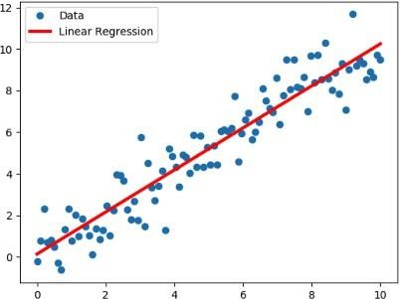

Figure: Linear Regression Model



You ll start with the simplest case, which is simple linear regression. There are five basic steps when you re implementing linear regression:

1. Import the packages and classes that you need.
2. Provide data to work with, and eventually do appropriate transformations.
3. Create a regression model and fit it with existing data.
4. Check the results of model fitting to know whether the model is satisfactory.
5. Apply the model for predictions.

These steps are more or less general for most of the regression approaches and implementations. Throughout the rest of the tutorial, you’ll learn how to do these steps for several different scenarios.



The first step is to import the package numpy and the class LinearRegression from sklearn.linear_model:

>>> from sklearn.linear_model import LinearRegression



>>>

import

numpy

as

np



Now, you have all the functionalities that you need to implement linear regression.

The fundamental data type of NumPy is the array type called numpy.ndarray. The rest of this tutorial uses the term  to refer to instances of the type numpy.ndarray.

You’ll use the class sklearn.linear_model.LinearRegression to perform linear and polynomial regression and make predictions accordingly.



The second step is defining data to work with. The inputs (regressors, 𝑥 ) and output (response,

) should be arrays or similar objects. This is the simplest way of providing data for regression:

>>> y = np.array([5, 20, 14, 32, 22, 38])



>>>

x

=

np

.

array([

5

,

15

,

25

,

35

,

45

,

55

])

.

reshape((

-

1

,

1

))



Now, you have two arrays: the input, x, and the output, y. You should call .reshape() on x because this array must

be  , or more precisely, it must have

and



. That’s exactly what the argument (-1, 1) of .reshape() specifies.

This is how x and y look now:

As you can see, x has two dimensions, and x.shape is (6, 1), while y has a single dimension, and y.shape is (6,).



array([

5

,

,

20

, 32,

14

,

22

38])



array([[

,

5]

[15]

,

[25]

,

[35]

,





The next step is to create a linear regression model and fit it using the existing data.

Create an instance of the class LinearRegression, which will represent the regression model

and output, x and y, as the arguments. In other words, .fit() . It returns self, which is the variable model itself. That’s why you can replace the last two statements with this one:

>>> model = LinearRegression().fit(x, y)



This statement does the same thing as the previous two. It’s just shorter.



Once you have your model fitted, you can get the results to check whether the model works satisfactorily and to interpret it. You can obtain the coefficient of determination, 𝑅 ², with .score() called on model:



>>>

r_sq

=

model

.

score(x,

y)

>>>

print

(

f

"coefficient of determination:

{

r_sq

}

"

)



When you’re applying .score(), the arguments are also the predictor x and response y, and the

return value is 𝑅 ².

The attributes of model are .intercept_, which represents the coefficient 𝑏 ₀, and .coef_, which

represents 𝑏 ₁:

|  |
| --- |
|  |
| >>> print(f"intercept: {model.intercept_}") intercept: 5.633333333333329  >>> print(f"slope: {model.coef_}") |

slope: [0.54]

The code above illustrates how to get 𝑏 o and 𝑏 ₁. You can notice that .intercept_ is a scalar, while .coef_ is an array.

The value of o is approximately 5.63. This illustrates that your model predicts the response 5.63 when is zero. The value ₁ = 0.54 means that the predicted response rises by 0.54 when

𝑥 is increased by one.

You’ll notice that you can provide y as a two-dimensional array as well. In this case, you’ll get a similar result. This is how it might look:

|  |
| --- |
| predicted response:  [ 8.33333333 13.73333333 19.13333333 24.53333333 29.93333333 35.33333333] |

When applying .predict(), you pass the regressor as the argument and get the corresponding predicted response. This is a nearly identical way to predict the response:



>>>

y_pred

=

model

.

intercept_

+

model

.

coef_

*

x

>>>

print

(

f

"predicted response:

\

n

{

y_pred

}

"

)

predicted

response:



In this case, you multiply each element of x with model.coef_ and add model.intercept_ to the product.

The output here differs from the previous example only in dimensions. The predicted response is now a twodimensional array, while in the previous case, it had one dimension.

If you reduce the number of dimensions of x to one, then these two approaches will yield the same result. You can do this by replacing x with x.reshape(-1), x.flatten(), or x.ravel() when multiplying it with model.coef_.



estate pricing strategies

1. Assisting clients in making informed decisions
2. Market analysis for regions in the USA
3. Predictive tool for estimating house prices

**Reference : -**

process involves exploring the data, data collection, model fitting, and interpretation of regression results. Practical skills in using statistical software for regression analysis are likely to be developed, enhancing students ability to analyze relationships between variables and make predictions based on linear model.

References – https://en.wikipedia.org/wiki/Linear_regression

https://[www.khanacademy.org/math/statistics-probability/describing-relationships-](http://www.khanacademy.org/math/statistics-probability/describing-relationships-)  quantitativedata/introduction-to-trend-lines/a/linear-regression-review

https://github.com/huzaifsayed/Linear-Regression-Model-for-House-Price- Prediction/blob/master/linear-regression-model.jpg

**Conclusion:** Thus Implemented a Linear Regression Model to predict house prices for regions in the USA using the provided dataset.

|  |  |
| --- | --- |
| **Lab Assignment**  **No.** | 02 |
| **Title** | Build a Multiclass classifier using the CNN model. Use MNIST or any other suitable dataset. a. Perform Data Pre-processing b. Define Model and perform training c. Evaluate Results using confusion matrix. |
| **Roll No.** |  |
| **Class** | BE |
| **Date of Completion** |  |
| **Subject** | Computer Laboratory-IV: Deep Learning |
| **Assessment Marks** |  |
| **Assessor's Sign** |  |

# ASSIGNMENT No: 02

**ASSIGNMENT No: 02**

**Title:-** Build a Multiclass classifier using the CNN model. Use MNIST or any other suitable dataset. a. Perform Data Pre-processing

1. Define Model and perform training
2. Evaluate Results using confusion matrix.



Building a multiclass classifier using a Convolutional Neural Network (CNN) using MNIST or any other suitable dataset. It involves several steps, including data pre-processing, defining the model architecture, training the model, and evaluating its performance using a confusion matrix.

Implement the technique of Convolution neural network (CNN)



* + Python (3.x recommended)
  + TensorFlow (Deep learning framework for building CNNs)
  + Jupyter Notebook, any Python IDE, or Google Colab (for running Python code)



* + A machine with at least 8GB of RAM is recommended for model training.
  + A multi-core CPU is suitable, and for faster training, a GPU (Graphics Processing Unit) is highly recommended.



* + Basic understanding of Python programming
  + Familiarity with the concepts of Neural Networks, especially Convolutional Neural Networks (CNNs)



https://github.com/AmritK10/MNIST-CNN

•

Numpy

-

for

linear

algebra.



* Pandas - for data analysis.
* Matplotlib - for data visualization. • Tensorflow - for neural networks.



ANN or Artificial Neural Network is a multi-layer fully-connected neural net that consists of many layers, including an input layer, multiple hidden layers, and an output layer. This is a very popular deep learning algorithm used in various classification tasks like audio and words Similarly, we have Convolutional Neural Networks(CNNs) for image classification.

is basically a model known to be and in recent times it has gained a lot of popularity because of its usefulness. CNN uses multilayer perceptrons to do computational works. CNN uses relatively little pre-processing compared to other image classification algorithms. This means the network learns through filters that in traditional algorithms were hand-engineered. So, for the image processing tasks CNNs are the best- suited option.



Applying a Convolutional Neural Network (CNN) on the MNIST dataset is a popular way to learn about and demonstrate the capabilities of CNNs for image classification tasks. The

MNIST dataset consists of 28×28 grayscale images of hand-written digits (0-9), with a training set of 60,000 examples and a test set of 10,000 examples.



1. Load and preprocess the data: The MNIST dataset can be loaded using the Keras library, and the images can be normalized to have pixel values between 0 and 1.
2. Define the model architecture: The CNN can be constructed using the Keras Sequential API, which allows for easy building of sequential models layer-by-layer. The architecture should typically include convolutional layers, pooling layers, and fully-connected layers.
3. Compile the model: The model needs to be compiled with a loss function, an optimizer, and a metric for evaluation.
4. Train the model: The model can be trained on the training set using the Keras fit() function. It is important to monitor the training accuracy and loss to ensure the model is converging properly.
5. Evaluate the model: The trained model can be evaluated on the test set using the Keras evaluate() function. The evaluation metric typically used for classification tasks is accuracy.



mnist dataset is a dataset of handwritten images as shown below in the image

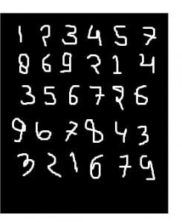

We can get 99.06% accuracy by using CNN(Convolutional Neural Network) with a functional model. The reason for using a functional model is to maintain easiness while connecting the layers.

1.



* Import necessary libraries, including TensorFlow and Keras.

2.



* Load the MNIST dataset, which consists of 28x28 grayscale images of handwritten digits (0 through

9).

* Pre-process the data by normalizing pixel values (between 0 and 1), reshaping images, and one-hot encoding labels.

3. 

* Design the CNN architecture with convolutional layers, pooling layers, and fully connected layers.
* Use activation functions like ReLU to introduce non-linearity.
* The final layer has 10 units with softmax activation for multiclass classification.

4. 

- Specify the optimizer (e.g., 'adam'), loss function (e.g., 'categorical_crossentropy' for multiclass classification), and evaluation metric (e.g., 'accuracy').

5. 

* Train the CNN using the training dataset.
* Specify the number of epochs (passes through the entire dataset) and batch size.

6. 

* Evaluate the trained CNN on the test dataset to assess its performance.
* Measure metrics such as accuracy to understand how well the model generalizes to unseen data.

These steps provide a comprehensive overview of the process involved in building and training a CNN for image classification using the MNIST dataset. Adjustments to these steps can be made based on specific model requirements and task objectives.

Recognizes handwritten digits (0-9) with applications in automated systems.

•

•

•



Processes checks by recognizing handwritten amounts and account numbers.

Recognizes postal codes on envelopes for automated mail sorting

* Classifies documents based on handwritten patterns or characters.

Analyzes medical images for detecting anomalies or identifying patterns.

•

•

•

transportation.



Recognizes handwritten characters in forms for efficient data entry

Recognizes hand gestures for sign language translation or device control

Reads and interprets product labels for inventory or quality control.

Identifies handwritten or printed characters on traffic signs for intelligent

* Analyzes historical handwritten documents for digitization and preservation.

CNN excels in diverse applications: finance (check processing), healthcare (image analysis), retail (label recognition), and transportation (sign recognition). It aids digitization efforts and ensures cultural heritage preservation. Overall, CNN offers valuable automation and efficiency across industries.



https://[www.geeksforgeeks.org/applying-convolutional-neural-network-on-mnist-dataset/](http://www.geeksforgeeks.org/applying-convolutional-neural-network-on-mnist-dataset/) https://[www.youtube.com/watch?v=9cPMFTwBdM4](http://www.youtube.com/watch?v=9cPMFTwBdM4)

**Conclusion:** Thus I Build a Multiclass classifier using the CNN model using MNIST or any other suitable dataset by Performing Data Pre-processing, Defining Model and perform training and Evaluating Results using confusion matrix.

|  |  |
| --- | --- |
| **Lab Assignment**  **No.** | 03 |
| **Title** | Design RNN or its variant including LSTM or GRU  a) Select a suitable time series dataset. E.g - Predict sentiments based on product reviews. b) Apply for prediction |
| **Roll No.** |  |
| **Class** | BE |
| **Date of Completion** |  |
| **Subject** | Computer Laboratory-IV- Deep learning |
| **Assessment Marks** |  |
| **Assessor's Sign** |  |

# ASSIGNMENT No: 03

**Title:-**

Design RNN or its variant including LSTM or GRU

a) Select a suitable time series dataset. E.g - Predict sentiments based on product reviews. b) Apply for prediction



Implement a Recurrent Neural Network (RNN) or its variant (LSTM or GRU) on a selected time series dataset, such as predicting sentiments based on product reviews, to develop a predictive model for sentiment analysis.

Solve the language translation problem by Recurrent neural network(RNN)



* Python (3.x recommended)
* Jupyter Notebook or any Python IDE or Google Colab



A machine with sufficient RAM and processing power for model training (8GB RAM recommended)



* Basic understanding of Python programming
* Familiarity with the concepts of Neural Networks



Inbuilt tensorflow-keras-imdb dataset



* Keras
* Tensorflow



Recurrent Neural Network (RNN)

Recurrent Neural Network is a generalization of feedforward neural network that has an internal memory. RNN is recurrent in nature as it performs the same function for every input of data while the output of the current input depends on the past one computation. After producing the output, it is copied and sent back into the recurrent network. For making a decision, it considers the current input and the output that it has learned from the previous input.

Unlike feedforward neural networks, RNNs can use their internal state (memory) to process sequences of inputs. This makes them applicable to tasks such as unsegmented, connected handwriting recognition or speech recognition. In other neural networks, all the inputs are independent of each other. But in RNN, all the inputs are related to each other.

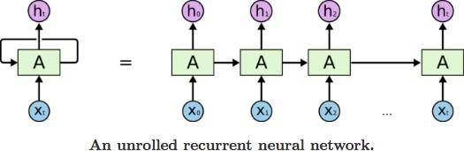

First, it takes the X(0) from the sequence of input and then it outputs h(0) which together with X(1) is the input for the next step. So, the h(0) and X(1) is the input for the next step. Similarly, h(1) from the next is the input with X(2) for the next step and so on. This way, it keeps remembering the context while training The formula for the current state is

. 

Applying Activation Function:



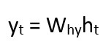W is weight, h is the single hidden vector, Whh is the weight at previous hidden state, Whx is the weight at current input state, tanh is the Activation funtion, that implements a Non-linearity that squashes the activations to the range[-1.1]

Yt is the output state. Why is the weight at the output state.

Long Short Term Memory (LSTM)

Long Short-Term Memory (LSTM) networks are a modified version of recurrent neural networks, which makes it easier to remember past data in memory. The vanishing gradient problem of RNN is resolved here. LSTM is well-suited to classify, process and predict time series given time lags of unknown duration. It trains the model by using back-propagation. In an LSTM network, three gates are present:

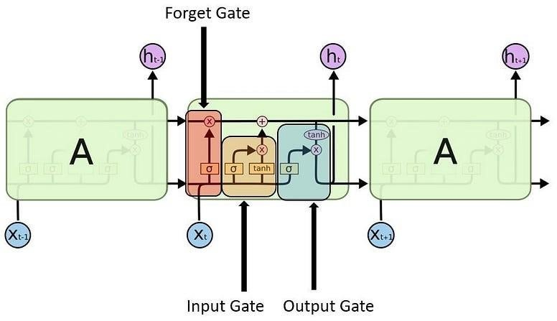

1. Input gate - discover which value from input should be used to modify the memory. Sigmoid function decides which values to let through 0,1. and tanh function gives weightage to the values which are passed deciding their level of importance ranging from-1 to 1.

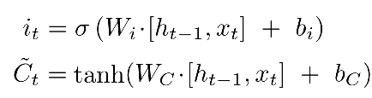

1. Forget gate - discover what details to be discarded from the block. It is decided by the sigmoid function. it looks at the previous state(ht-1) and the content input(Xt) and outputs a number between 0(omit this)and 1(keep this)for each number in the cell state Ct−1.

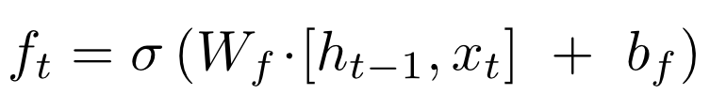

1. 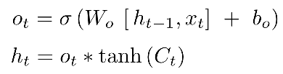Output gate — the input and the memory of the block is used to decide the output. Sigmoid function decides which values to let through 0,1. and tanh function gives weightage to the values which are passed deciding their level of importance ranging from-1 to 1 and multiplied with output of Sigmoid.
2. Load IMDb Movie Reviews dataset (50,000 reviews)

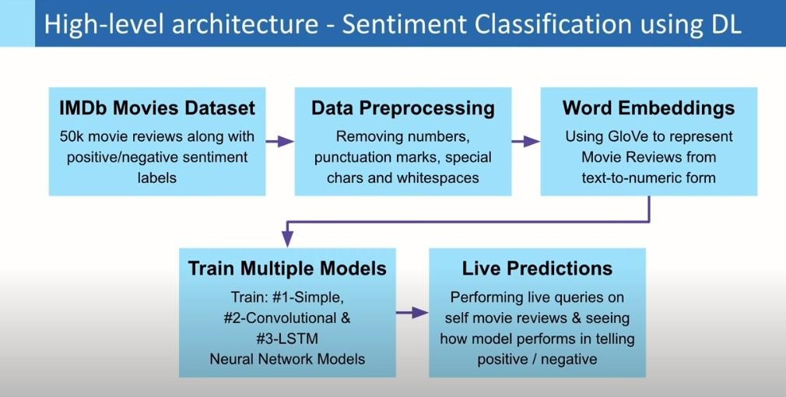

1. Pre-process dataset by removing special characters, numbers, etc. from user reviews + convert sentiment labels positive & negative to numbers 1 & 0, respectively

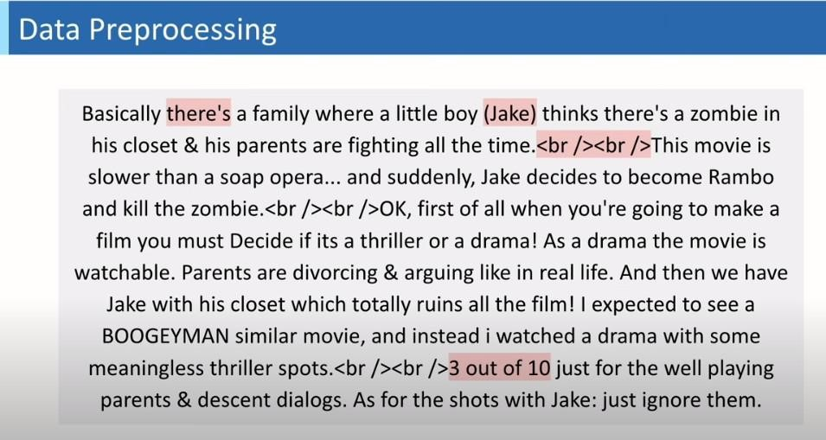

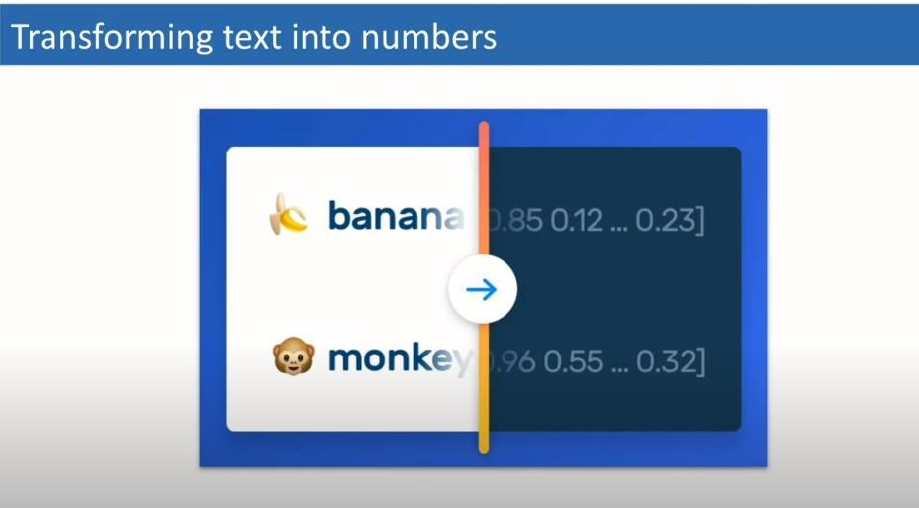

1. Import GloVe Word Embedding to build Embedding Dictionary + Use this to build Embedding Matrix for our Corpus

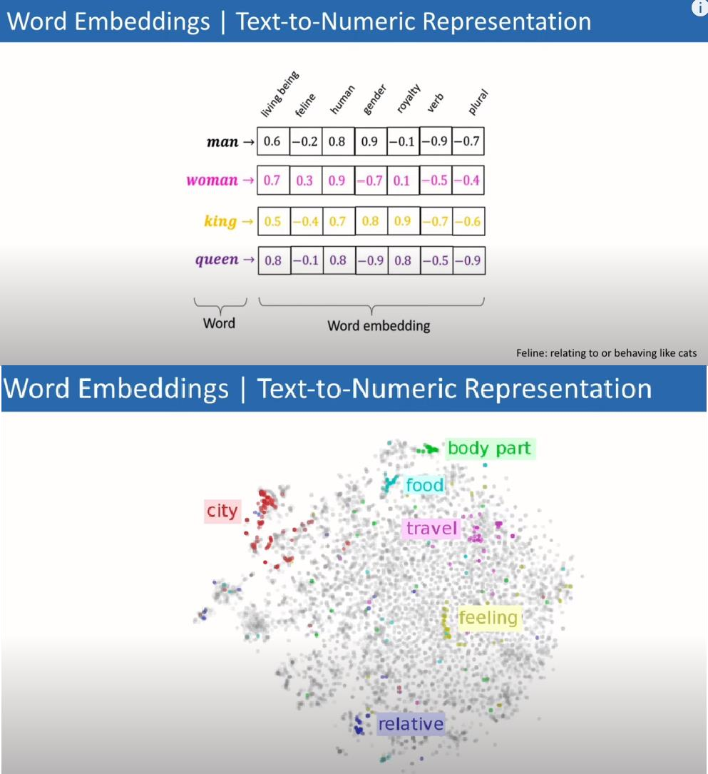

1. Model Training using Deep Learning in Keras for separate: Simple Neural Net, CNN and LSTM Models



1) Product Review Sentiment Analysis:

Predict sentiment (positive, negative, neutral) from user reviews for product improvement insights. 2) Customer Feedback Analysis:

Analyze sentiments in customer feedback to understand overall satisfaction and identify areas for improvement. 3) Brand Monitoring:

Monitor social media for product mentions and analyze sentiments to assess brand perception. 4) Market Research:

Analyze sentiments in market surveys to gauge consumer opinions about specific products or features. 5) Quality Assurance in E-commerce:

Automatically categorize and flag reviews with negative sentiments to improve product quality.

The process involves data preparation, embedding, model design, training, and evaluation.

The use of different architectures such as Simple Neural Net, CNN, and LSTM allows for comparison and analysis of their performance on sentiment prediction for IMDb movie reviews. The GloVe Word Embedding enhances the models' understanding of the textual data.

Finally, predictions are made on real IMDb movie reviews to assess the models' applicability and accuracy.



https://aditi-mittal.medium.com/understanding-rnn-and-lstm-f7cdf6dfc14e https://colah.github.io/posts/2015-08-Understanding-LSTMs/ https://youtu.be/oWo9SNcyxlI?si=0OzO6SUYZ_FxbTgY

**Conclusion:** Thus Designed RNN or its variant including LSTM or GRU

|  |  |
| --- | --- |
| **Lab Assignment**  **No.** | 04 |
| **Title** | Design and implement a CNN for Image Classification a) Select a suitable image classification dataset (medical imaging, agricultural,  etc.). b) Optimized with different hyper-parameters including learning rate, filter size, no. of layers, optimizers, dropouts, etc |
| **Roll No.** |  |
| **Class** | BE |
| **Date of Completion** |  |
| **Subject** | Computer Laboratory-IV: Deep Learning |
| **Assessment Marks** |  |
| **Assessor's Sign** |  |

# ASSIGNMENT No: 04

### Title:-

Design and implement Union, Intersection, Complement and Difference operations on fuzzy sets. Also create fuzzy relations by Cartesian product of any two fuzzy sets and perform max-min composition on any two fuzzy relations.

**Problem Statement:** Design and implement Union, Intersection, Complement, and Difference operations on fuzzy sets. Create fuzzy relations by the Cartesian product of any two fuzzy sets and perform max-min composition on any two fuzzy relations.

**Objective:**

1. To implement Union, Intersection, Complement, and Difference operations on fuzzy sets.
2. To create fuzzy relations using the Cartesian product of fuzzy sets and perform max-min composition on fuzzy relations.
3. To demonstrate the application of these operations in fuzzy logic.

**Outcome-**

1. Successfully implement Union, Intersection, Complement, and Difference operations on fuzzy sets.
2. Create fuzzy relations using the Cartesian product of fuzzy sets and perform max-min composition on fuzzy relations.

**Software Requirement**

* Python (3.x recommended)
* Jupyter Notebook or any Python IDE

**Hardware Requirement**

A machine with sufficient RAM and processing power for model training (8GB RAM recommended)

**Prerequisities-**

What is Fuzzy Set ?

Fuzzy refers to something that is unclear or vague . Hence, Fuzzy Set is a Set where every key is associated with value, which is between 0 to 1 based on the certainty .This value is often called as degree of membership. Fuzzy Set is denoted with a Tilde Sign on top of the normal Set notation.

Operations on Fuzzy Set with Code :

1. Union :

### Operations on Fuzzy Set with Code :

1. **Union :** Consider 2 Fuzzy Sets denoted by A and B, then let’s consider Y be the Union of them, then for every member of A and B, Y will be:

### degree_of_membership(Y)= max(degree_of_membership(A), degree_of_membership(B)) EXAMPLE :

# Example to Demonstrate the # Union of Two Fuzzy Sets

A = dict() B = dict() Y = dict()

A = {"a": 0.2, "b": 0.3, "c": 0.6, "d": 0.6}

B = {"a": 0.9, "b": 0.9, "c": 0.4, "d": 0.5}

print('The First Fuzzy Set is :', A) print('The Second Fuzzy Set is :', B) for A_key, B_key in zip(A, B):

A_value = A[A_key] B_value = B[B_key]

if A_value > B_value:

Y[A_key] = A_value

else:

Y[B_key] = B_value

print('Fuzzy Set Union is :', Y)

### Output

The First Fuzzy Set is : {'a': 0.2, 'b': 0.3, 'c': 0.6, 'd': 0.6}

The Second Fuzzy Set is : {'a': 0.9, 'b': 0.9, 'c': 0.4, 'd': 0.5}

Fuzzy Set Union is : {'a': 0.9, 'b': 0.9, 'c': 0.6, 'd': 0.6}

### Intersection :

Consider 2 Fuzzy Sets denoted by A and B, then let’s consider Y be the Intersection of them, then for every member of A and B, Y will be:

degree_of_membership(Y)= min(degree_of_membership(A), degree_of_membership(B))

### EXAMPLE :

# Example to Demonstrate

# Intersection of Two Fuzzy Sets A = dict()

B = dict() Y = dict()

A = {"a": 0.2, "b": 0.3, "c": 0.6, "d": 0.6}

B = {"a": 0.9, "b": 0.9, "c": 0.4, "d": 0.5}

print('The First Fuzzy Set is :', A) print('The Second Fuzzy Set is :', B) for A_key, B_key in zip(A, B):

A_value = A[A_key] B_value = B[B_key] if A_value < B_value:

Y[A_key] = A_value

else:

Y[B_key] = B_value

print('Fuzzy Set Intersection is :', Y)

### Output

The First Fuzzy Set is : {'a': 0.2, 'b': 0.3, 'c': 0.6, 'd': 0.6}

The Second Fuzzy Set is : {'a': 0.9, 'b': 0.9, 'c': 0.4, 'd': 0.5}

Fuzzy Set Intersection is : {'a': 0.2, 'b': 0.3, 'c': 0.4, 'd': 0.5}

### Complement :

Consider a Fuzzy Sets denoted by A , then let’s consider Y be the Complement of it, then for every member of A , Y will be:

degree_of_membership(Y)= 1 - degree_of_membership(A)

### EXAMPLE :

# Example to Demonstrate the

# Difference Between Two Fuzzy Sets A = dict()

Y = dict()

A = {"a": 0.2, "b": 0.3, "c": 0.6, "d": 0.6}

print('The Fuzzy Set is :', A) for A_key in A:

Y[A_key]= 1-A[A_key]

print('Fuzzy Set Complement is :', Y)

### Output

The Fuzzy Set is : {'a': 0.2, 'b': 0.3, 'c': 0.6, 'd': 0.6}

Fuzzy Set Complement is : {'a': 0.8, 'b': 0.7, 'c': 0.4, 'd': 0.4}

### Difference :

Consider 2 Fuzzy Sets denoted by A and B, then let’s consider Y be the Intersection of them, then for every member of A and B, Y will be:

degree_of_membership(Y)= min(degree_of_membership(A), 1- degree_of_membership(B))

### EXAMPLE :

# Example to Demonstrate the

# Difference Between Two Fuzzy Sets A = dict()

B = dict() Y = dict()

A = {"a": 0.2, "b": 0.3, "c": 0.6, "d": 0.6}

B = {"a": 0.9, "b": 0.9, "c": 0.4, "d": 0.5}

print('The First Fuzzy Set is :', A) print('The Second Fuzzy Set is :', B) for A_key, B_key in zip(A, B):

A_value = A[A_key] B_value = B[B_key] B_value = 1 - B_value if A_value < B_value:

Y[A_key] = A_value

else:

Y[B_key] = B_value

print('Fuzzy Set Difference is :', Y)

**Conclusion:** Fuzzy logic provides a powerful framework for dealing with uncertainty and imprecision in data. By implementing operations on fuzzy sets and relations, we can model complex relationships and make more flexible decisions in various applications such as control systems, artificial intelligence, and pattern recognition. The Union, Intersection, Complement, and Difference operations allow us to manipulate fuzzy sets, while fuzzy relations and max-min composition enable us to represent and combine fuzzy relationships between sets. These operations and techniques expand the capabilities of traditional logic and set theory, offering a more nuanced approach to handling vague and ambiguous infor

|  |  |
| --- | --- |
| **Lab Assignment**  **No.** | 06 |
| **Title** | Import Data from different Sources such as (Excel, Sql Server, Oracle etc.) and load in targeted system. |
| **Roll No.** |  |
| **Class** | BE |
| **Date of Completion** |  |
| **Subject** | Computer Laboratory-IV: Business Intelligence |
| **Assessment Marks** |  |
| **Assessor's Sign** |  |

# ASSIGNMENT No: 06

**Problem Statement:** Import Data from different Sources such as (Excel, Sql Server, Oracle etc.) and load in targeted system.

**Title:** Import Data from different Sources such as (Excel, Sql Server, Oracle etc.) and load in targeted system.

**Problem Statement:** Import Data from different Sources such as (Excel, Sql Server, Oracle etc.) and load in targeted system.

**Prerequisite:**

Basics of Python

**Software Requirements:** Power BI Tool

**Hardware Requirements:** PIV, 2GB RAM, 500 GB HDD

**Learning Objectives:**

Learn to import data from different sources such as(Excel, Sql Server, Oracle etc.) and load in targeted system.

**Outcomes:**

After completion of this assignment students are able to understand how to import data from different sources such as(Excel, Sql Server, Oracle etc.) and load in targeted system.

**Theory:**

**What is Legacy Data?**

Legacy data, according to Business Dictionary, is "information maintained in an old or outof-date format or computer system that is consequently challenging to access or handle."

**Sources of Legacy Data**

Where does legacy data come from? Virtually everywhere. Figure 1 indicates that there are many sources from which you may obtain legacy data. This includes existing databases, often relational, although non-RDBs such as hierarchical, network, object, XML, object/relational databases, and NoSQL databases. Files, such as XML documents or "flat files"ù such as configuration files and comma-delimited text files, are also common sources of legacy data. Software, including legacy applications that have been wrapped ( perhaps via CORBA) and

access to existing information. The point to be made is that there is often far more to gaining access to legacy data than simply writing an SQL query against an existing relational database.

legacy services such as web services or CICS transactions, can also provide access to existing information. The point to be made is that there is often far more to gaining

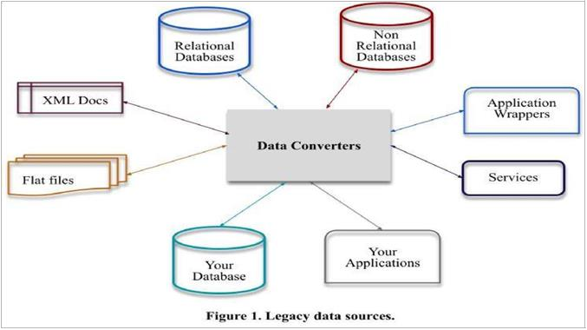

***Importing Excel Data***

1. Launch Power BI Desktop.
2. From the Home ribbon, select Get Data. Excel is one of the Most Common data connections, so you can select it directly from the Get Data menu

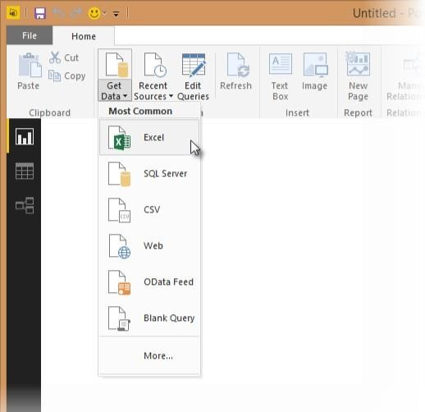

1. If you select the Get Data button directly, you can also select FIle > Excel and select Connect.
2. In the Open File dialog box, select the Products.xlsx file.
3. In the Navigator pane, select the Products table and then select Edit.

***Importing Data from OData Feed***

In this task, you'll bring in order data. This step represents connecting to a sales system. You import data into Power BI Desktop from the sample Northwind OData feed at the following URL, which you can copy (and then paste) in the steps below: <http://services.odata.org/V3/Northwind/Northwind.svc/>Connect to an OData feed:

1. rom the Home ribbon tab in Query Editor, select Get Data.
2. Browse to the OData Feed data source.
3. In the OData Feed dialog box, paste the URL for the Northwind OData feed.
4. Select OK.
5. In the Navigator pane, select the Orders table, and then select Edit.

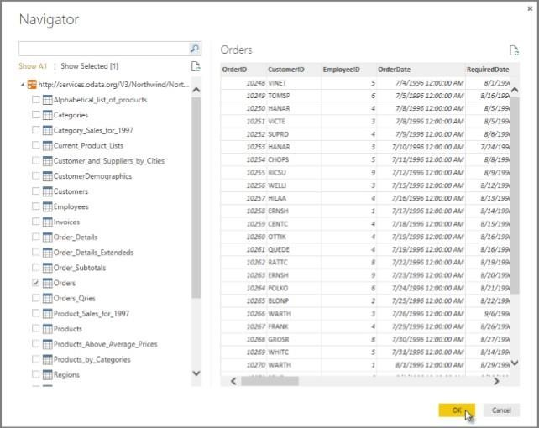

**Conclusion: -** This way, Implemented a program for inverted files.

|  |  |
| --- | --- |
| **Lab Assignment**  **No.** | 07 |
| **Title** | Data Visualization from Extraction Transformation and Loading (ETL) Process. |
| **Roll No.** |  |
| **Class** | BE |
| **Date of**  **Completion** |  |
| **Subject** | Computer Laboratory-IV-Business Intelligence |
| **Assessment**  **Marks** |  |
| **Assessor's**  **Sign** |  |

# ASSIGNMENT No: 07

**Title:** Data Visualization from Extraction Transformation and Loading (ETL) Process.

**Problem Statement:** Data Visualization from Extraction Transformation and Loading (ETL) Process.

**Prerequisite:**

Basics of Python

**Software Requirements:**[Jupyter](https://cocalc.com/features/jupyter-notebook)**Hardware Requirements:**

PIV, 2GB RAM, 500 GB HDD

**Outcomes:**

After completion of this assignment students are able to understand how Data Visualization is done through Extraction Transformation and Loading (ETL) Process **Theory:**

Extract, transform, and load (ETL) are 3 data processes, followed after [data collection.](https://apandre.wordpress.com/data/collector/) Extraction takes data, collected in data sources like flat files, databases (relational, hierarchical etc.), transactional datastores, semi-structured repositories (e.g. email systems or document libraries) with different structure and format, pre-validating extracted data and parsing valid data to destination (e.g. staging database)

Transformation takes extracted data and applies predefined rules and functions to it, including selection (e.g.

ignore or remove NULLs), data cleansing, encoding (e.g. mapping “Male” to “M”), deriving (e.g. calculating designated value as a product of extracted value and predefined constant) , sorting, joining data from multiple sources (e.g. lookup or merge), aggregation (e.g. summary for each month), transposing (columns to rows or vice versa), splitting, disaggregation, lookups (e.g. validation through dictionaries), predefined validation etc. which may lead to rejection of some data. Transformed data can be stored into Data Warehouse (DW).

Load takes transformed data and places it into end target, in most cases called Data Mart ( sometimes they called Data Warehouse too). Load can append, refresh or/and overwrite preexisting data, apply constraints and execute appropriate triggers (to enforce data integrity, uniqueness, mandatory fields, provide log etc.) and may start additional processes, like data backup or replication.

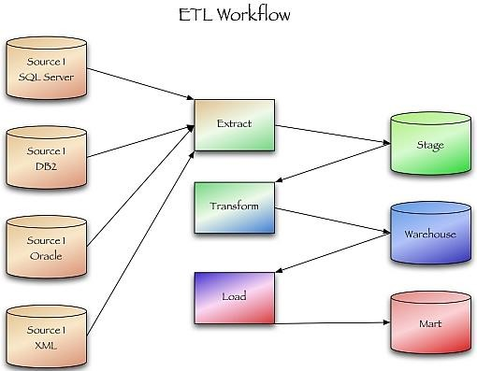

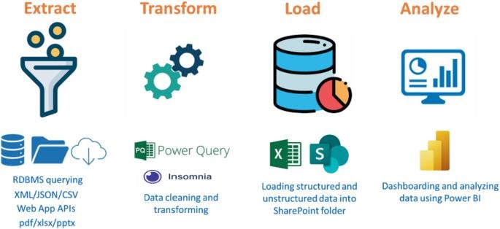

**Conclusion:**-

This way Data Visualization from Extraction Transformation and Loading (ETL) Process is done.

|  |  |
| --- | --- |
| **Lab Assignment**  **No.** | 8 |
| **Title** | Perform the Extraction Transformation and Loading (ETL) process to construct the database in the Sql server / Power BI. |
| **Roll No.** |  |
| **Class** | BE |
| **Date of Completion** |  |
| **Subject** | Computer Laboratory-IV-Business Intelligence |
| **Assessment Marks** |  |
| **Assessor's Sign** |  |

# ASSIGNMENT No: 08

**Title:** Perform the Extraction Transformation and Loading (ETL) process to construct the database in the Sql server / Power BI.

**Problem Statement:** Perform the Extraction Transformation and Loading (ETL) process to construct the database in the Sql server / Power BI.

**Prerequisite:**

Basics of Python

**Software Requirements:**[Jupyter](https://cocalc.com/features/jupyter-notebook)**Hardware Requirements:**

PIV, 2GB RAM, 500 GB HDD

**Outcomes:**

After completion of this assignment students are able to understand how to Perform the Extraction Transformation and Loading (ETL) process to construct the database in the Sql server / Power BI.

**Theory:**

**Step 1 : Data Extraction :**

The data extraction is first step of ETL. There are 2 Types of Data Extraction

Full Extraction : All the data from source systems or operational systems gets extracted to staging area. (Initial Load)

Partial Extraction : Sometimes we get notification from the source system to update specific date. It is called as Delta load.

Source System Performance: The Extraction strategies should not affect source system performance.

**Step 2 : Data Transformation :**

The data transformation is second step.After extracting the data there is big need to do the transformation as per the target system.I would like to give you some bullet points of Data Transformation.

* + Data Extracted from source system is in to Raw format. We need to transform it before loading in to target server.
  + Data has to be cleaned, mapped and transformed.
  + There are following important steps of Data Transformation :

1. **Selection :** Select data to load in target
2. **Matching :** Match the data with target system
3. **Data Transforming :** We need to change data as per target table structures
   * Character set conversion : Need to transform the character sets as per the target systems. (Firstname and last name example)
   * Calculated and derived values: In source system there is first val and second val and in target we need the calculation of first val and second val.
   * Data Conversion in different formats : If in source system date in in DDMMYY format and in target the date is in DDMONYYYY format then this transformation needs to be done at transformation phase.

## Step 3 : Data Loading

• [Data loading p](https://www.vskills.in/certification/tutorial/data-mining-and-warehousing/data-loading-types-and-modes/)hase loads the prepared data from staging tables to main tables.

ETL process in SQL Server:

Following are the steps to open BIDS\SSDT.

**Step 1** − Open either BIDS\SSDT based on the version from the Microsoft SQL Server programs group. The following screen appears

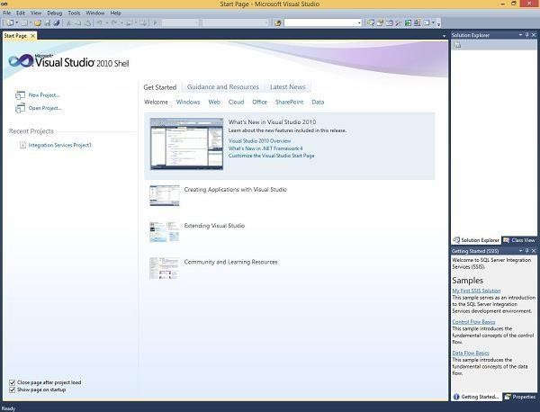

**Step 2** − The above screen shows SSDT has opened. Go to file at the top left corner in the above image and click New. Select project and the following screen opens.

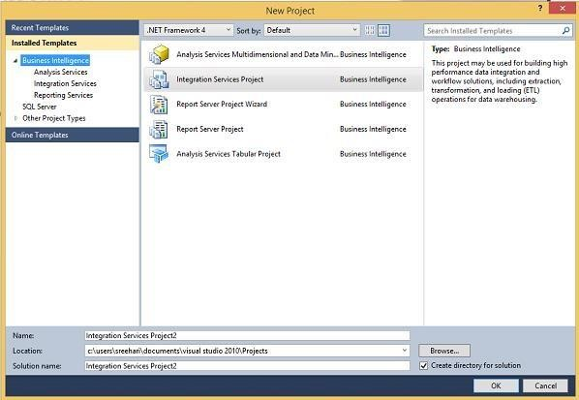

**Step 3** − Select Integration Services under Business Intelligence on the top left corner in the above screen to get the following screen.

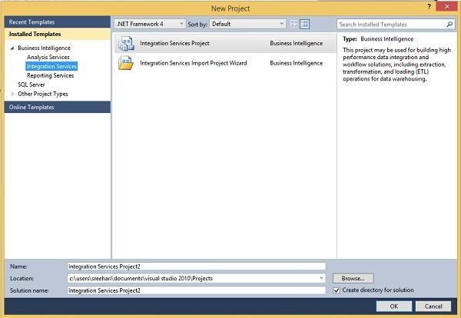

**Step 4** − In the above screen, select either Integration Services Project or Integration Services Import Project Wizard based on your requirement to develop\create the package.

There are two modes − Native Mode (SQL Server Mode) and Share Point Mode.

There are two models − Tabular Model (For Team and Personal Analysis) and Multi Dimensions Model (For Corporate Analysis).

The BIDS (Business Intelligence Studio till 2008 R2) and SSDT (SQL Server Data Tools from 2012) are environments to work with SSAS.

## ETL Process in Power BI

**1) Remove other columns to only display columns of interest**

Power BI Desktop includes Query Editor, which is where you shape and transform your data connections. Query Editor opens automatically when you select **Edit** from Navigator. You can also open the Query Editor by selecting Edit Queries from the Home ribbon in Power BI Desktop. The following steps are performed in Query Editor.

1. In **Query Editor**, select the **ProductID, ProductName**, **QuantityPerUnit,** and **UnitsInStock** columns (use **Ctrl+Click** to select more than one column, or **Shift+Click** to select columns that are beside each other).
2. Select **Remove Columns > Remove** Other Columns from the ribbon, or right-click on a column header and click Remove Other Columns.

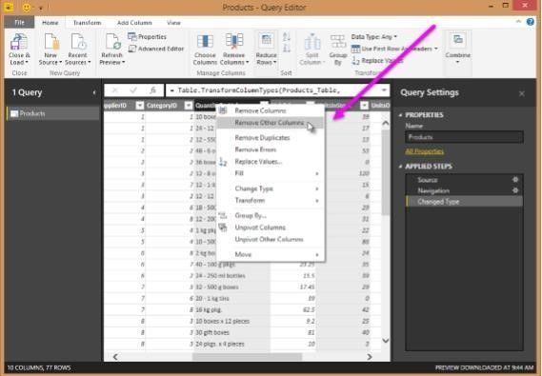

1. **Change the data type of the UnitsInStock column**

When Query Editor connects to data, it reviews each field and to determine the best data type. For the Excel workbook, products in stock will always be a whole number, so in this step you confirm the **UnitsInStock** column’s datatype is Whole Number.

1. Select the **UnitsInStock** column.
2. Select the **Data Type drop-down button** in the **Home ribbon**.
3. If not already a Whole Number, select **Whole Number** for data type from the drop down (the Data Type: button also displays the data type for the current selection).
4. When we attempt to create the relationship, we see that one already exists! As shown in the Create Relationship dialog (by the shaded columns), the ProductsID fields in each query already have an established relationship.

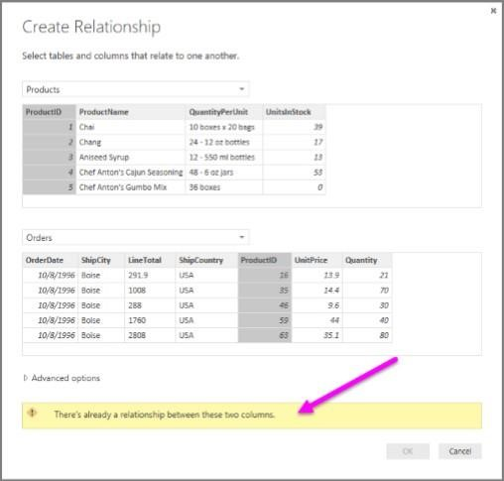

1. Select Cancel, and then select Relationship view in Power BI Desktop.
2. When you double-click the arrow on the line that connects the to queries, an Edit Relationship dialog appears.

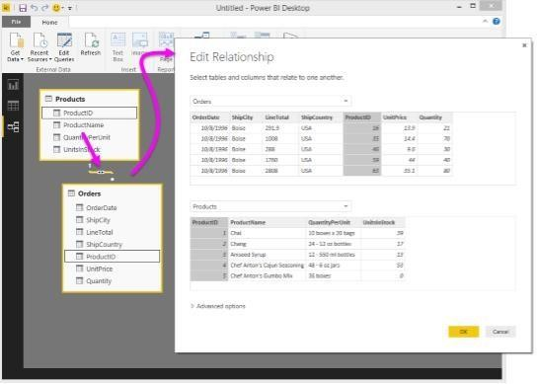

**Conclusion:** Thus Performed Extraction Transformation and Loading (ETL) process to construct the database in the Sql server / Power BI.

**Assignment :11**

**AIM:** To Develop a MapReduce program to calculate the frequency of a given word in agiven file **Map Function** – It takes a set of data and converts it into another set of data, where individual elements are broken down into tuples (Key-Value pair).

**Example –** (Map function in Word Count)

### Input

Set of data

Bus, Car, bus, car, train, car, bus, car, train, bus, TRAIN,BUS, buS, caR, CAR, car, BUS, TRAIN

### Output

Convert into another set of data (Key,Value)

(Bus,1), (Car,1), (bus,1), (car,1), (train,1), (car,1), (bus,1), (car,1), (train,1), (bus,1),

(TRAIN,1),(BUS,1), (buS,1), (caR,1), (CAR,1), (car,1), (BUS,1), (TRAIN,1)

**Reduce Function –** Takes the output from Map as an input and combines those data tuples into a smaller set of tuples.

Example – (Reduce function in Word Count)

**Input** Set of Tuples (output of Map function)

(Bus,1), (Car,1), (bus,1), (car,1), (train,1), (car,1), (bus,1), (car,1), (train,1), (bus,1), (TRAIN,1),(BUS,1),

(buS,1),(caR,1),(CAR,1), (car,1), (BUS,1), (TRAIN,1)

### Output Converts into smaller set of tuples

**(BUS,7), (CAR,7), (TRAIN,4)**

### Work Flow of Program

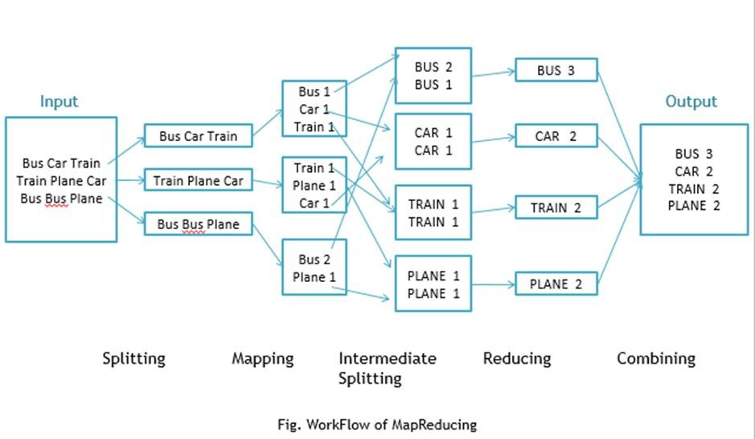

## Workflow of MapReduce consists of 5 steps

1. **Splitting –** The splitting parameter can be anything, e.g. splitting by space, comma, semicolon, or even by a new line (‘\n’).
2. **Mapping –** as explained above
3. Intermediate splitting – the entire process in parallel on different clusters. In order to group them in “Reduce Phase” the similar KEY data should be on same cluster.
4. **Reduce –** it is nothing but mostly group by phase
5. **Combining –** The last phase where all the data (individual result set from each cluster) is combine together to form a Result

## Now Let’s See the Word Count Program in Java

**Make sure that Hadoop is installed on your system with java idk Steps to follow**

## Step 1. Open Eclipse> File > New > Java Project > (Name it – MRProgramsDemo) > Finish

**Step 2. Right Click > New > Package ( Name it - PackageDemo) > Finish Step 3. Right Click on Package > New > Class (Name it - WordCount) Step 4. Add Following Reference Libraries –**

## Right Click on Project > Build Path> Add External Archivals

* /usr/lib/hadoop-0.20/hadoop-core.jar
* Usr/lib/hadoop-0.20/lib/Commons-cli-1.2.jar

## Program: Step 5. Type following Program :

package PackageDemo; import java.io.IOException;

import org.apache.hadoop.conf.Configuration; import org.apache.hadoop.fs.Path;

import org.apache.hadoop.io.IntWritable; import org.apache.hadoop.io.LongWritable; import org.apache.hadoop.io.Text;

import org.apache.hadoop.mapreduce.Job; import org.apache.hadoop.mapreduce.Mapper; import org.apache.hadoop.mapreduce.Reducer;

import org.apache.hadoop.mapreduce.lib.input.FileInputFormat; import org.apache.hadoop.mapreduce.lib.output.FileOutputFormat; import org.apache.hadoop.util.GenericOptionsParser;

public class WordCount {

public static void main(String [] args) throws Exception

{

Configuration c=new Configuration();

String[] files=new GenericOptionsParser(c,args).getRemainingArgs(); Path input=new Path(files[0]);

Path output=new Path(files[1]); Job j=new Job(c,"wordcount"); j.setJarByClass(WordCount.class);

j.setMapperClass(MapForWordCount.class); j.setReducerClass(ReduceForWordCount.class); j.setOutputKeyClass(Text.class); j.setOutputValueClass(IntWritable.class); FileInputFormat.addInputPath(j, input); FileOutputFormat.setOutputPath(j, output); System.exit(j.waitForCompletion(true)?0:1);

}

public static class MapForWordCount extends Mapper<LongWritable, Text, Text, IntWritable>{

public void map(LongWritable key, Text value, Context con) throws IOException, InterruptedException

{

String line = value.toString();

String[] words=line.split(","); for(String word: words )

{

Text outputKey = new Text(word.toUpperCase().trim()); IntWritable outputValue = new IntWritable(1); con.write(outputKey, outputValue);

}

}

}

public static class ReduceForWordCount extends Reducer<Text, IntWritable, Text, IntWritable>

{

public void reduce(Text word, Iterable<IntWritable> values, Context con) throws IOException,

InterruptedException

{

int sum = 0;

for(IntWritable value : values)

{

sum += value.get();

}

con.write(word, new IntWritable(sum));

}

}

}

## Make Jar File

Right Click on Project> Export> Select export destination as Jar File > next> Finish

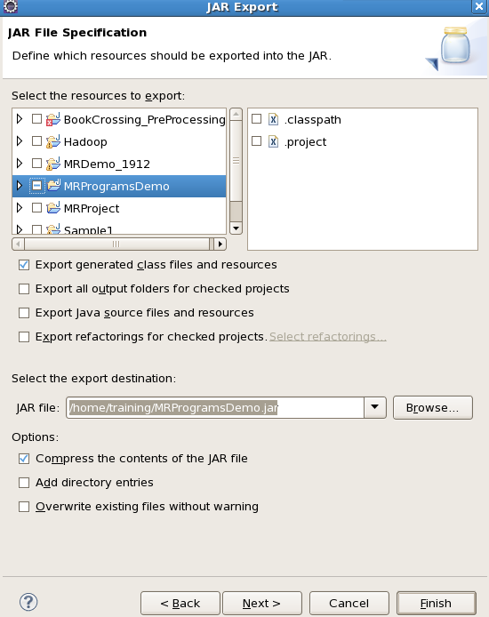

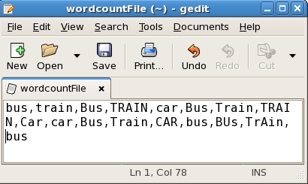

To Move this into Hadoop directly, open the terminal and enter the following commands:

[training@localhost ~]$ hadoop fs -put wordcountFile wordCountFile

## Run Jar file

(Hadoop jar jarfilename.jar packageName.ClassName PathToInputTextFile PathToOutputDirectry)

## [training@localhost ~]$ Hadoop jar MRProgramsDemo.jar PackageDemo.WordCount wordCountFile MRDir1

**Result: Open Result**

[training@localhost ~]$ hadoop fs -ls MRDir1 Found 3 items

-rw-r--r-- 1 training supergroup

0 2016-02-23 03:36 /user/training/MRDir1/_SUCCESS drwxr-xr-x - training supergroup

0 2016-02-23 03:36 /user/training/MRDir1/_logs

-rw-r--r-- 1 training supergroup

20 2016-02-23 03:36 /user/training/MRDir1/part-r-00000 [training@localhost ~]$ hadoop fs -cat MRDir1/part-r-00000 BUS 7

CAR 4

TRAIN 6

**Assignment 12**

Develop a MapReduce program to find the grades of student’s**.**

import java.util.Scanner; public class JavaExample

{

public static void main(String args[])

{

/* This program assumes that the student has 6 subjects,

* thats why I have created the array of size 6. You can
* change this as per the requirement.

*/

int marks[] = new int[6]; int i;

float total=0, avg;

Scanner scanner = new Scanner(System.in); for(i=0; i<6; i++) {

System.out.print("Enter Marks of Subject"+(i+1)+":"); marks[i] = scanner.nextInt();

total = total + marks[i];

}

scanner.close();

//Calculating average here avg = total/6;

System.out.print("The student Grade is: ");

if(avg>=80)

{

System.out.print("A");

}

else if(avg>=60 && avg<80)

{

System.out.print("B");

}

else if(avg>=40 && avg<60)

{

System.out.print("C");

}

else

{

System.out.print("D");

}

}

}

# Expected Output:

Enter Marks of Subject1:40 Enter Marks of Subject2:80 Enter Marks of Subject3:80

Enter Marks of Subject4:40

Enter Marks of Subject5:60 Enter Marks of Subject6:60 The student Grade is: B

# Actual Output

### Result:

**Assignment 13:**

Develop a Map Reduce program to implement Matrix Multiplication.

In **mathematics**, **matrix multiplication** or the **matrix product** is a binary operation that produces a matrix from two matrices. The definition is motivated by linear equations and linear transformations on vectors, which have numerous applications in applied mathematics, physics, and engineering. In more detail, if **A** is an *n × m* matrix and **B** is an *m × p* matrix, their matrix product **AB** is an *n × p* matrix, in which the m entries across a row of **A** are multiplied with the m entries down a column of **B** and summed to produce an entry of **AB**. When two linear transformations are represented by matrices, then the matrix product represents the composition of the two transformations.

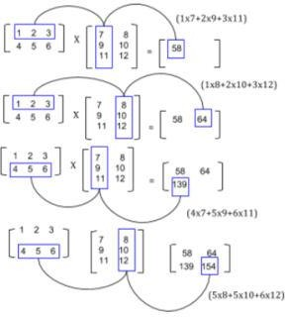

# Algorithm for Map Function.

1. for each element mij of M do

produce (key,value) pairs as ((i,k), (M,j,mij), for k=1,2,3,.. upto the number of columns of N

1. for each element njk of N do

produce (key,value) pairs as ((i,k),(N,j,Njk), for i = 1,2,3,.. Upto the number of rows of M.

1. return Set of (key,value) pairs that each key (i,k), has list with values

(M,j,mij) and (N, j,njk) for all possible values of j.

# Algorithm for Reduce Function.

1. for each key (i,k) do
2. sort values begin with M by j in listM sort values begin with N by j in listN multiply mij and njk for jth value of each list
3. sum up mij x njk return (i,k), Σj=1 mij x njk

# Step 1. Download the hadoop jar files with these links.

Download Hadoop Common Jar files: https://goo.gl/G4MyHp

$ wget https://goo.gl/G4MyHp -O hadoop-common-2.2.0.jar Download Hadoop Mapreduce Jar File: https://goo.gl/KT8yfB

$ wget https://goo.gl/KT8yfB -O hadoop-mapreduce-client-core-2.7.1.jar

# Step 2. Creating Mapper file for Matrix Multiplication.

import java.io.DataInput; import java.io.DataOutput; import java.io.IOException; import java.util.ArrayList;

import org.apache.hadoop.conf.Configuration; import org.apache.hadoop.fs.Path;

import org.apache.hadoop.io.DoubleWritable; import org.apache.hadoop.io.IntWritable; import org.apache.hadoop.io.Text;

import org.apache.hadoop.io.Writable;

import org.apache.hadoop.io.WritableComparable; import org.apache.hadoop.mapreduce.Job;

import org.apache.hadoop.mapreduce.Mapper; import org.apache.hadoop.mapreduce.Reducer; import org.apache.hadoop.mapreduce.lib.input.*; import org.apache.hadoop.mapreduce.lib.output.*; import org.apache.hadoop.util.ReflectionUtils;

class Element implements Writable { int tag;

int index; double value; Element() {

tag = 0;

index = 0;

value = 0.0;

}

Element(int tag, int index, double value) { this.tag = tag;

this.index = index; this.value = value;

}

@Override

public void readFields(DataInput input) throws IOException { tag = input.readInt();

index = input.readInt(); value = input.readDouble();

}

@Override

public void write(DataOutput output) throws IOException { output.writeInt(tag);

output.writeInt(index); output.writeDouble(value);

}

}

class Pair implements WritableComparable<Pair> { int i;

int j;

Pair() {

i = 0;

j = 0;

}

Pair(int i, int j) {

this.i = i; this.j = j;

}

@Override

public void readFields(DataInput input) throws IOException { i = input.readInt();

j = input.readInt();

}

@Override

public void write(DataOutput output) throws IOException { output.writeInt(i);

output.writeInt(j);

}

@Override

public int compareTo(Pair compare) { if (i > compare.i) {

return 1;

} else if ( i < compare.i) { return -1;

} else {

if(j > compare.j) {

return 1;

} else if (j < compare.j) { return -1;

}

}

return 0;

}

public String toString() { return i + " " + j + " ";

}

}

public class Multiply {

public static class MatriceMapperM extends Mapper<Object,Text,IntWritable,Element>

@Override

public void map(Object key, Text value, Context context) throws IOException, InterruptedException {

String readLine = value.toString(); String[] stringTokens = readLine.split(",");

int index = Integer.parseInt(stringTokens[0]);

double elementValue = Double.parseDouble(stringTokens[2]); Element e = new Element(0, index, elementValue); IntWritable keyValue = new

IntWritable(Integer.parseInt(stringTokens[1]));

context.write(keyValue, e);

}

}

public static class MatriceMapperN extends Mapper<Object,Text,IntWritable,Element> { @Override

public void map(Object key, Text value, Context context) throws IOException, InterruptedException {

String readLine = value.toString(); String[] stringTokens = readLine.split(",");

int index = Integer.parseInt(stringTokens[1]);

double elementValue = Double.parseDouble(stringTokens[2]); Element e = new Element(1,index, elementValue);

IntWritable keyValue = new IntWritable(Integer.parseInt(stringTokens[0]));

context.write(keyValue, e);

}

}

public static class ReducerMxN extends Reducer<IntWritable,Element, Pair, DoubleWritable> {

@Override

public void reduce(IntWritable key, Iterable<Element> values, Context context) throws IOException, InterruptedException {

ArrayList<Element> M = new ArrayList<Element>(); ArrayList<Element> N = new ArrayList<Element>(); Configuration conf = context.getConfiguration(); for(Element element : values) {

Element tempElement = ReflectionUtils.newInstance(Element.class,

conf);

ReflectionUtils.copy(conf, element, tempElement);

if (tempElement.tag == 0) { M.add(tempElement);

} else if(tempElement.tag == 1) { N.add(tempElement);

}

}

for(int i=0;i<M.size();i++) {

for(int j=0;j<N.size();j++) {

Pair p = new Pair(M.get(i).index,N.get(j).index);

double multiplyOutput = M.get(i).value * N.get(j).value;

context.write(p, new DoubleWritable(multiplyOutput));

}

}

}

}

public static class MapMxN extends Mapper<Object, Text, Pair, DoubleWritable> { @Override

public void map(Object key, Text value, Context context) throws IOException, InterruptedException {

String readLine = value.toString(); String[] pairValue = readLine.split(" "); Pair p = new

Pair(Integer.parseInt(pairValue[0]),Integer.parseInt(pairValue[1]));

DoubleWritable val = new DoubleWritable(Double.parseDouble(pairValue[2]));

context.write(p, val);

}

}

public static class ReduceMxN extends Reducer<Pair, DoubleWritable, Pair, DoubleWritable> {

@Override

public void reduce(Pair key, Iterable<DoubleWritable> values, Context context) throws IOException, InterruptedException {

double sum = 0.0; for(DoubleWritable value : values) {

sum += value.get();

}

context.write(key, new DoubleWritable(sum));

}

}

public static void main(String[] args) throws Exception { Job job = Job.getInstance(); job.setJobName("MapIntermediate"); job.setJarByClass(Project1.class);

MultipleInputs.addInputPath(job, new Path(args[0]), TextInputFormat.class, MatriceMapperM.class);

MultipleInputs.addInputPath(job, new Path(args[1]), TextInputFormat.class, MatriceMapperN.class);

job.setReducerClass(ReducerMxN.class); job.setMapOutputKeyClass(IntWritable.class); job.setMapOutputValueClass(Element.class); job.setOutputKeyClass(Pair.class); job.setOutputValueClass(DoubleWritable.class); job.setOutputFormatClass(TextOutputFormat.class); FileOutputFormat.setOutputPath(job, new Path(args[2])); job.waitForCompletion(true);

Job job2 = Job.getInstance(); job2.setJobName("MapFinalOutput");

job2.setJarByClass(Project1.class);

job2.setMapperClass(MapMxN.class); job2.setReducerClass(ReduceMxN.class);

job2.setMapOutputKeyClass(Pair.class); job2.setMapOutputValueClass(DoubleWritable.class);

job2.setOutputKeyClass(Pair.class); job2.setOutputValueClass(DoubleWritable.class);

job2.setInputFormatClass(TextInputFormat.class); job2.setOutputFormatClass(TextOutputFormat.class);

FileInputFormat.setInputPaths(job2, new Path(args[2])); FileOutputFormat.setOutputPath(job2, new Path(args[3]));

job2.waitForCompletion(true);

}

}

# Step 5. Compiling the program in particular folder named as operation

#!/bin/bash

rm -rf multiply.jar classes

module load hadoop/2.6.0 mkdir -p classes

javac -d classes -cp classes:`$HADOOP_HOME/bin/hadoop classpath` Multiply.java jar cf multiply.jar -C classes .

echo "end"

# Step 6. Running the program in particular folder named as operation

export HADOOP_CONF_DIR=/home/$USER/cometcluster module load hadoop/2.6.0

myhadoop-configure.sh start-dfs.sh

start-yarn.sh

hdfs dfs -mkdir -p /user/$USER

hdfs dfs -put M-matrix-large.txt /user/$USER/M-matrix-large.txt hdfs dfs -put N-matrix-large.txt /user/$USER/N-matrix-large.txt

hadoop jar multiply.jar edu.uta.cse6331.Multiply /user/$USER/M-matrix-large.txt

/user/$USER/N-matrix-large.txt /user/$USER/intermediate /user/$USER/output rm -rf output-distr

mkdir output-distr

hdfs dfs -get /user/$USER/output/part* output-distr

stop-yarn.sh stop-dfs.sh

myhadoop-cleanup.sh

### Expected Output:

module load hadoop/2.6.0 rm -rf output intermediate

hadoop --config $HOME jar multiply.jar edu.uta.cse6331.Multiply M-matrix-small.txt N-matrix- small.txt intermediate output

**Actual Output:**

**Result:**

**Assignment 14**

**AIM:** Develop a MapReduce program to analyze Titanic ship data and to find the average age of the people (both male and female) who died in the tragedy. How many persons are survived in each class.

The titanic data will be..

Column 1 :PassengerI d Column 2 : Survived (survived=0 &died=1) Column 3 :Pclass Column 4 : Name

Column 5 : Sex Column 6 : Age

Column 7 :SibSp Column 8 :Parch

Column 9 : Ticket Column 10 : Fare

Column 11 :Cabin Column 12 : Embarked

### Description:

There have been huge disasters in the history of Map reduce, but the magnitude of the Titanic’s disaster ranks as high as the depth it sank too. So much so that subsequent disasters have always been described as “titanic in proportion” – implying huge losses.

Anyone who has read about the Titanic, know that a perfect combination of natural events and human errors led to the sinking of the Titanic on its fateful maiden journey from Southampton to New York on April 14, 1912.

There have been several questions put forward to understand the cause/s of the tragedy – foremost among them is: What made it sink and even more intriguing How can a 46,000 ton ship sink to the depth of 13,000 feet in a matter of 3 hours? This is a mind boggling question indeed!

There have been as many inquisitions as there have been questions raised and equally that many types of analysis methods applied to arrive at conclusions. But this blog is not about analyzing why or what made the Titanic sink – it is about analyzing the data that is present about the Titanic publicly. It actually uses Hadoop MapReduce to analyze and arrive at:

* The average age of the people (both male and female) who died in the tragedy using Hadoop MapReduce.
* How many persons survived – traveling class wise.

This blog is about analyzing the data of Titanic. This total analysis is performed in Hadoop MapReduce.

### This Titanic data is publically available and the Titanic data set is described below under the heading Data Set Description.

**Using that dataset we will perform some Analysis and will draw out some insights like finding the average age of male and females died in Titanic, Number of males and females died in each compartment.**

### DATA SET DESCRIPTION

Column 1 : PassengerI

Column 2 : Survived (survived=0 & died=1) Column 3 : Pclass Column 4 : Name

Column 5 : Sex Column 6 : Age Column 7 : SibSp Column 8 : Parch Column 9

: Ticket Column 10 : Fare Column 11 : Cabin Column 12 : Embarked

# Mapper code:

public class Average_age {

public static class Map extends Mapper<LongWritable, Text, Text, IntWritable> { private Text gender = new Text();

private IntWritable age = new IntWritable();

public void map(LongWritable key, Text value, Context context ) throws IOException, InterruptedException {

String line = value.toString(); String str[]=line.split(","); if(str.length>6){ gender.set(str[4]); if((str[1].equals("0")) ){

if(str[5].matches("\\d+")){ int i=Integer.parseInt(str[5]);

age.set(i);

}

}

}

context.write(gender, age)

}

}

# Reducer Code:

public static class Reduce extends Reducer<Text,IntWritable, Text, IntWritable> { public void reduce(Text key, Iterable<IntWritable> values, Context context) throws IOException, InterruptedException {

int sum = 0; int l=0;

for (IntWritable val : values) { l+=1;

sum += val.get();

}

sum=sum/l;

context.write(key, new IntWritable(sum));

}

}

**Configuration Code:** job.setMapOutputKeyClass(Text.class); job.setMapOutputValueClass(IntWritable.class);

# https://github.com/kiran0541/Map- Reduce/blob/master/Average%20age%20of%20male%20and%20female%20 people%20died%20in%20titanic

# Way to to execute the Jar file to get the result of the first problem statement:

***hadoop jar average.jar /TitanicData.txt /avg_out***

Here ‘hadoop’ specifies we are running a Hadoop command and jar specifies which type of application we are running and average.jar is the jar file which we have created which consists the above source code and the path of the Input file name in our case it is TitanicData.txt and the output file where to store the output here we have given it as avg out.

# Way to view the output:

hadoop dfs –cat /avg_out/part-r-00000

Here ‘hadoop’ specifies that we are running a Hadoop command and ‘dfs‘ specifies that we are performing an operation related to Hadoop Distributed File System and ‘- cat’ is used to view the contents of a file and ‘avg_out/part-r-00000’ is the file where the output is stored. Part file is created by default by the TextInputFormat class of Hadoop.

# Output:

### Result:

**Assignment: 15**

Hive: Introduction Creation of Database and Table, Hive Partition, Hive Built in Function and Operators, Hive View and Index.

### Description:

[Hive](http://infolab.stanford.edu/~ragho/hive-icde2010.pdf) is an open-source data warehousing solution built on top of Hadoop. It supports an SQL-like query language called HiveQL. These queries are compiled into MapReduce jobs that are executed on Hadoop. While Hive uses Hadoop for execution of queries, it reduces the effort that goes into writing and maintaining MapReduce jobs.

Hive supports database concepts like tables, columns, rows and partitions. Both primitive (integer, float, string) and complex data-types(map, list, struct) are supported. Moreover, these types can be composed to support structures of arbitrary complexity. The tables are serialized/deserialized using default serializers/deserializer. Any new data format and type can be supported by implementing SerDe and ObjectInspector java interface.

### RESOURCES:

VMWare, XAMPP Server, Web Browser, 1GB RAM, Hard Disk 80 GB.

### PROGRAM LOGIC:

SYNTAX for HIVE Database Operations DATABASE Creation

CREATE DATABASE|SCHEMA [IF NOT EXISTS] <database name>

Drop Database Statement

DROP DATABASE StatementDROP (DATABASE|SCHEMA) [IF EXISTS]

database_name [RESTRICT|CASCADE]; Creating and Dropping Table in HIVE

CREATE [TEMPORARY] [EXTERNAL] TABLE [IF NOT EXISTS] [db_name.]

table_name

[(col_name data_type [COMMENT col_comment], ...)]

[COMMENT table_comment] [ROW FORMAT row_format] [STORED AS file_format]

Loading Data into table log_data Syntax:

LOAD DATA LOCAL INPATH '<path>/u.data' OVERWRITE INTO TABLE

u_data;

Alter Table in HIVE Syntax

ALTER TABLE name RENAME TO new_name

ALTER TABLE name ADD COLUMNS (col_spec[, col_spec ...]) ALTER TABLE name DROP [COLUMN] column_name

ALTER TABLE name CHANGE column_name new_name new_type ALTER TABLE name REPLACE COLUMNS (col_spec[, col_spec ...]) Creating and Dropping View

CREATE VIEW [IF NOT EXISTS] view_name [(column_name [COMMENT

column_comment], ...) ] [COMMENT table_comment] AS SELECT ...

Dropping View Syntax:

DROP VIEW view_name Functions in HIVE

String Functions:- round(), ceil(), substr(), upper(), reg_exp() etc

Date and Time Functions:- year(), month(), day(), to_date() etc Aggregate Functions :- sum(), min(), max(), count(), avg() etc INDEXES

CREATE INDEX index_name ON TABLE base_table_name (col_name, ...) AS 'index.handler.class.name'

[WITH DEFERRED REBUILD]

[IDXPROPERTIES (property_name=property_value, ...)] [IN TABLE index_table_name]

[PARTITIONED BY (col_name, ...)] [

[ ROW FORMAT ...] STORED AS ...

| STORED BY ...

]

[LOCATION hdfs_path] [TBLPROPERTIES (...)]

Creating Index

CREATE INDEX index_ip ON TABLE log_data(ip_address) AS 'org.apache.hadoop.hive.ql.index.compact.CompactIndexHandler' WITH DEFERRED REBUILD;

Altering and Inserting Index

ALTER INDEX index_ip_address ON log_data REBUILD; Storing Index Data in Metastore

SET

hive.index.compact.file=/home/administrator/Desktop/big/metastore_db/tmp/index_ipadd ress_result;

SET

hive.input.format=org.apache.hadoop.hive.ql.index.compact.HiveCompactIndexInputFor mat;

Dropping Index

DROP INDEX INDEX_NAME on TABLE_NAME;

### OUTPUT:

### Result:

**Assignment : 17**

AIM: Implement a Deep Q-Network (DQN) using a deep neural network library (e.g., TensorFlow or PyTorch) and train it on a simple environment like CartPole or Mountain Car.

**Q Learning**

Let‟s say we know the expected reward of each action at every step. This would essentially be like a cheat sheet for the agent! Our agent will know exactly which action to perform.

It will perform the sequence of actions that will eventually generate the maximum total reward. This total reward is also called the Q-value and we will formalise our strategy as:

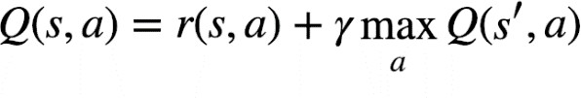

The above equation states that the Q-value yielded from being at state *s* and performing action *a* is the immediate reward r(s,a) plus the highest Q-value possible from the next state *s’*. Gamma here is the discount factor which controls the contribution of rewards further in the future.

Q(s‟,a) again depends on Q(s”,a) which will then have a coefficient of gamma squared. So, the Q- value depends on Q-values of future states as shown here:

https://s3-ap-south-1.amazonaws.com/av-blog-media/wp-content/uploads/2019/04/Screenshot-2019-04-17-at-7.15.35-PM.png

Adjusting the value of gamma will diminish or increase the contribution of future rewards.

Since this is a recursive equation, we can start with making arbitrary assumptions for all q-values. With experience, it will converge to the optimal policy. In practical situations, this is implemented as an update:

https://s3-ap-south-1.amazonaws.com/av-blog-media/wp-content/uploads/2019/04/Screenshot-2019-03-26-at-7.57.30-PM1.png

where alpha is the learning rate or step size. This simply determines to what extent newly acquired information overrides old information.

**Why ‘Deep’ Q-Learning?**

Q-learning is a simple yet quite powerful algorithm to create a cheat sheet for our agent. This helps the agent figure out exactly which action to perform.

But what if this cheatsheet is too long? Imagine an environment with 10,000 states and 1,000 actions per state. This would create a table of 10 million cells. Things will quickly get out of control!

It is pretty clear that we can‟t infer the Q-value of new states from already explored states. This presents two problems:

* First, the amount of memory required to save and update that table would increase as the number of states increases
* Second, the amount of time required to explore each state to create the required Q-table would be unrealistic

Here‟s a thought – what if we approximate these Q-values with machine learning models such as a neural network? Well, this was the idea behind DeepMind‟s algorithm that led to its acquisition by Google for 500 million dollars!

## Deep Q-Networks

In deep Q-learning, we use a neural network to approximate the Q-value function. The state is given as the input and the Q-value of all possible actions is generated as the output. The comparison between Q-learning & deep Q-learning is wonderfully illustrated below:

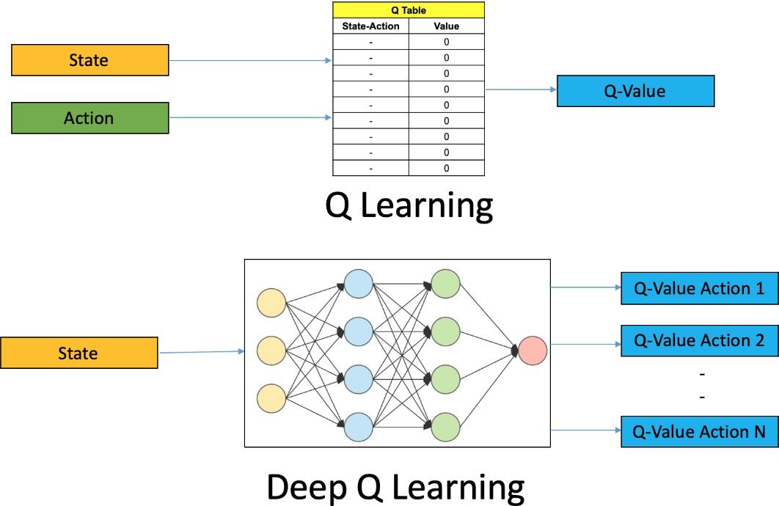

So, what are the steps involved in reinforcement learning using deep Q-learning networks (DQNs)?

* 1. All the past experience is stored by the user in memory
  2. The next action is determined by the maximum output of the Q-network
  3. The loss function here is mean squared error of the predicted Q-value and the target Q-value

– Q*. This is basically a regression problem. However, we do not know the target or actual value here as we are dealing with a reinforcement learning problem. Going back to the Q- value update equation derived fromthe Bellman equation. we have:



The section in green represents the target. We can argue that it is predicting its own value, but since R is the unbiased true reward, the network is going to update its gradient using backpropagation to finally converge.

## Challenges in Deep RL as Compared to Deep Learning

So far, this all looks great. We understood how neural networks can help the agent learn the best actions. However, there is a challenge when we compare deep RL to deep learning (DL):

* **Non-stationary or unstable target:** Let us go back to the pseudocode for deep Q-learning:

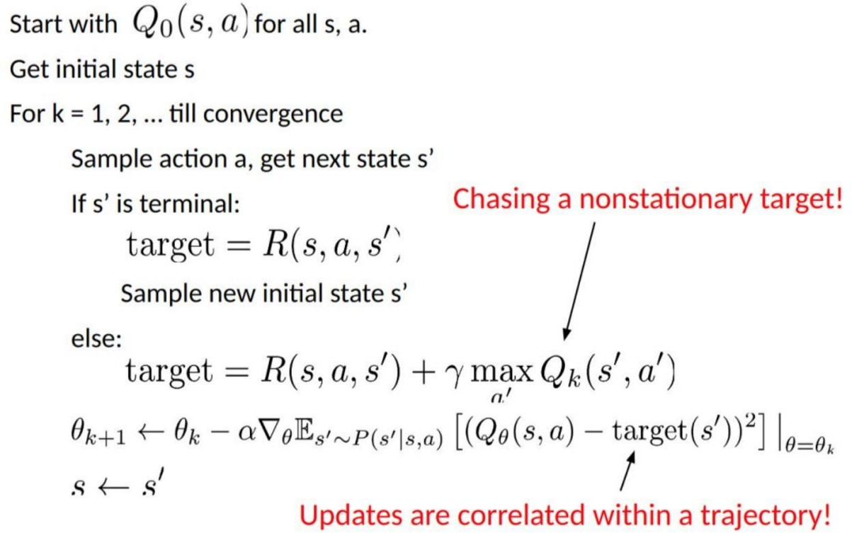

As you can see in the above code, the target is continuously changing with each iteration. In deep learning, the target variable does not change and hence the training is stable, which is just not true for RL.

To summarise, we often depend on the policy or value functions in reinforcement learning to sample actions. However, this is frequently changing as we continuously learn what to explore. As we play out the game, we get to know more about the ground truth values of states and actions and hence, the output is also changing.

So, we try to learn to map for a constantly changing input and output. But then what is the solution?

##### Target Network

Since the same network is calculating the predicted value and the target value, there could be a lot of divergence between these two. So, instead of using 1one neural network for learning, we can use two.

We could use a separate network to estimate the target. This target network has the same architecture as the function approximator but with frozen parameters. For every C iterations (a hyperparameter), the parameters from the prediction network are copied to the target network. This leads to more stable training because it keeps the target function fixed (for a while):

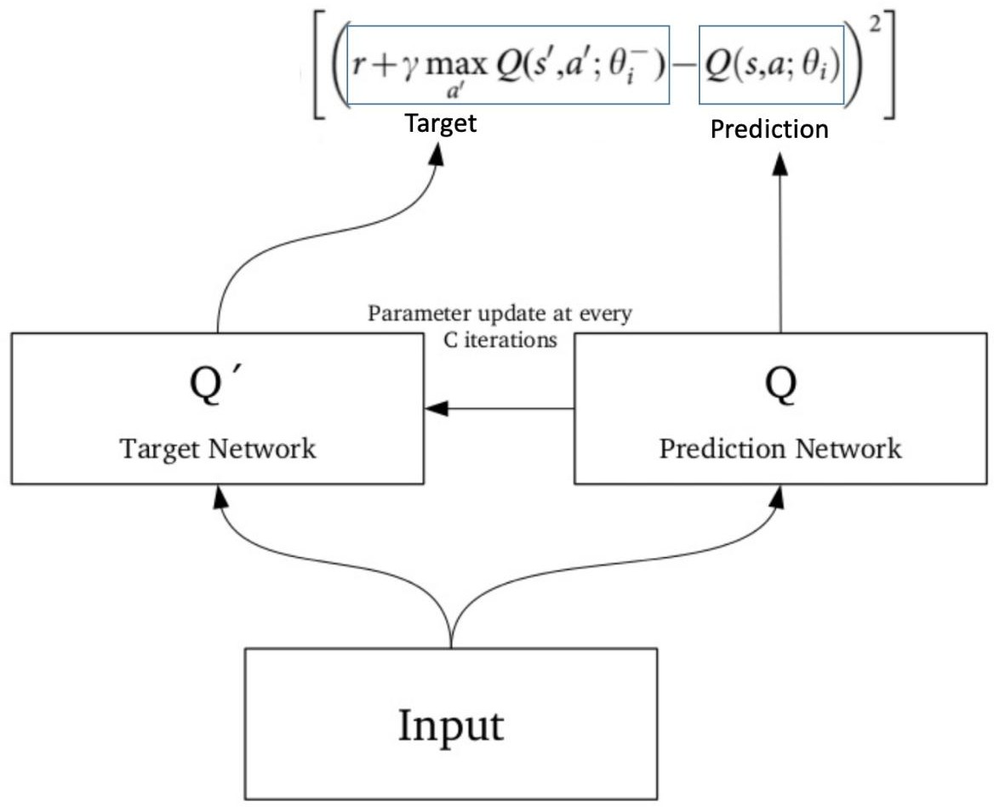

##### Experience Replay

*To perform experience replay, we store the agent’s experiences –* 𝑒𝑡=(𝑠𝑡,𝑎𝑡,𝑟𝑡,𝑠𝑡+1) What does the above statement mean? Instead of running Q-learning on state/action pairs as they occur during simulation or the actual experience, the system stores the data discovered for [state, action, reward, next_state] – in a large table.

Let‟s understand this using an example.

Suppose we are trying to build a video game bot where each frame of the game represents a different state. During training, we could sample a random batch of 64 frames from the last 100,000 frames to train our network. This would get us a subset within which the correlation amongst the samples is low and will also provide better sampling efficiency.

## Putting it all Together

The concepts we have learned so far? They all combine to make the deep Q-learning algorithm that was used to achive human-level level performance in Atari games (using just the video frames of the game).

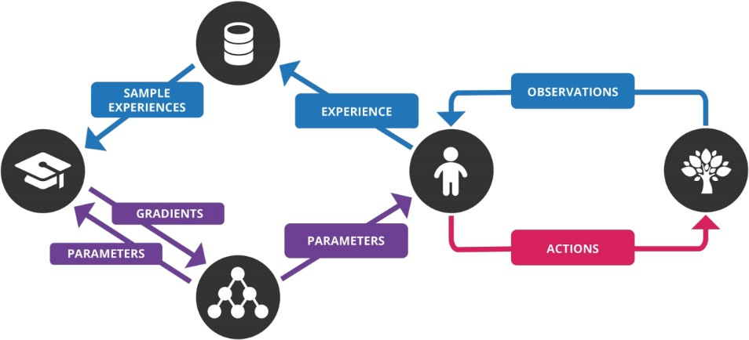

I have listed the steps involved in a deep Q-network (DQN) below:

* 1. Preprocess and feed the game screen (state s) to our DQN, which will return the Q-values of all possible actions in the state
  2. Select an action using the epsilon-greedy policy. With the probability epsilon, we select a random action *a*and with probability 1-epsilon, we select an action that has a maximum Q- value, such as a = argmax(Q(s,a,w))
  3. Perform this action in a state *s* and move to a new state *s’* to receive a reward. This state s‟ is the preprocessed image of the next game screen. We store this transition in our replay buffer as <s,a,r,s‟>
  4. Next, sample some random batches of transitions from the replay buffer and calculate the loss
  5. It is known that: https://s3-ap-south-1.amazonaws.com/av-blog-media/wp-content/uploads/2019/04/Screenshot-2019-04-17-at-1.06.52-PM.pngwhich is just the squared

difference between target Q and predicted Q

* 1. Perform gradient descent with respect to our actual network parameters in order to minimize this loss
  2. After every C iterations, copy our actual network weights to the target network weights
  3. Repeat these steps for *M* number of episodes

## Implementing Deep Q-Learning in Python using Keras & OpenAI Gym

Alright, so we have a solid grasp on the theoretical aspects of deep Q-learning. How about seeing it in action now? That‟s right – let‟s fire up our Python notebooks!

We will make an agent that can play a game called CartPole. We can also use an Atari game but training an agent to play that takes a while (from a few hours to a day). The idea behind our approach will remain the same so you can try this on an Atari game on your machine.

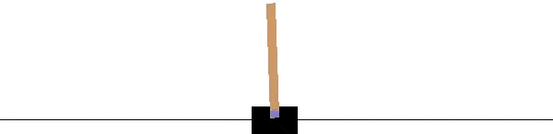

CartPole is one of the simplest environments in the OpenAI gym (a game simulator). As you can see in the above animation, the goal of CartPole is to balance a pole that‟s connected with one joint on top of a moving cart.

Instead of pixel information, there are four kinds of information given by the state (such as the angle of the pole and position of the cart). An agent can move the cart by performing a series of actions of 0 or 1, pushing the cart left or right.

We will use the *keras-rl* library here which lets us implement deep Q-learning out of the box.

Step 1: Install keras-rl library

From the terminal, run the following code block:

git clone https://github.com/matthiasplappert/keras-rl.git

cd keras-rl

python setup.py install

Step 2: Install dependencies for the CartPole environment

Assuming you have pip installed, you need to install the following libraries:

pip install h5py

pip install gym

Step 3: Let’s get started!

First, we have to import the necessary modules:

import numpy as np

import gym

from keras.models import Sequential

from keras.layers import Dense, Activation, Flatten

from keras.optimizers import Adam

from rl.agents.dqn import DQNAgent

from rl.policy import EpsGreedyQPolicy

from rl.memory import SequentialMemory

Then, set the relevant variables:

ENV_NAME = 'CartPole-v0'

# Get the environment and extract the number of actions available in the Cartpole problem

env = gym.make(ENV_NAME)

np.random.seed(123)

env.seed(123)

nb_actions = env.action_space.n

Next, we will build a very simple single hidden layer neural network model:

model = Sequential()

model.add(Flatten(input_shape=(1,) + env.observation_space.shape))

model.add(Dense(16))

model.add(Activation('relu'))

model.add(Dense(nb_actions))

model.add(Activation('linear'))

print(model.summary())

Now, configure and compile our agent. We will set our policy as Epsilon Greedy and our memory as Sequential Memory because we want to store the result of actions we performed and the rewards we get for each action.

policy = EpsGreedyQPolicy()

memory = SequentialMemory(limit=50000, window_length=1)

dqn = DQNAgent(model=model, nb_actions=nb_actions, memory=memory, nb_steps_warmup=10,

target_model_update=1e-2, policy=policy)

dqn.compile(Adam(lr=1e-3), metrics=['mae'])

# Okay, now it's time to learn something! We visualize the training here for show, but this slows down training quite a lot.

dqn.fit(env, nb_steps=5000, visualize=True, verbose=2)

Test our reinforcement learning model:

dqn.test(env, nb_episodes=5, visualize=True)

This will be the output of our model:

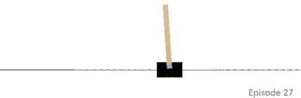

Not bad! Congratulations on building your very first deep Q-learning model.